**연습문제 해답**

**<1장 연습문제 해 답>**

**- 연결연산자 1번 문제 답:**

**- 연결 연산자 2번 문제 답:**

**- 연결 연산자 3번 문제 답:**

**<2장 일반함수 연습문제 해답>**

**- SUBSTR / INSTR 퀴즈 답:**

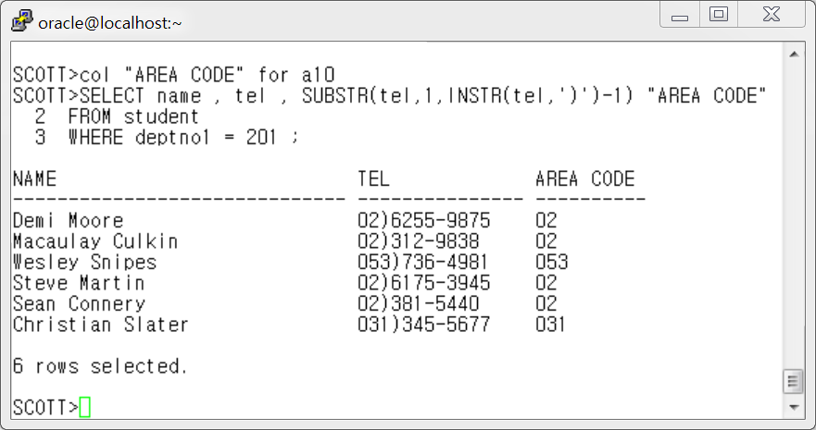

**- LPAD 퀴즈 답:**

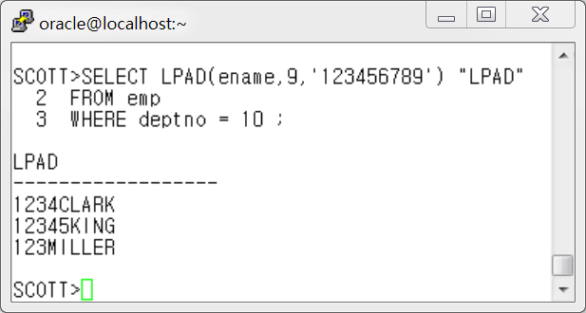

**- RPAD 퀴즈 답 :**

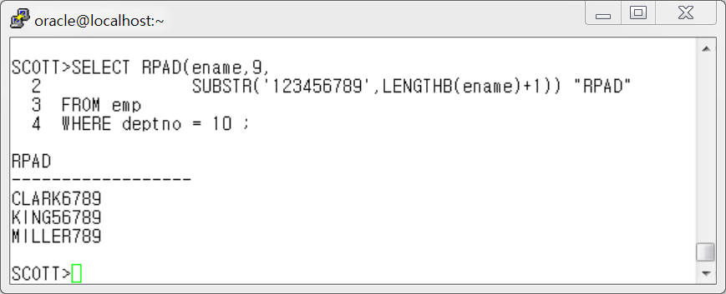

**- REPLACE 퀴즈 1 답 :**

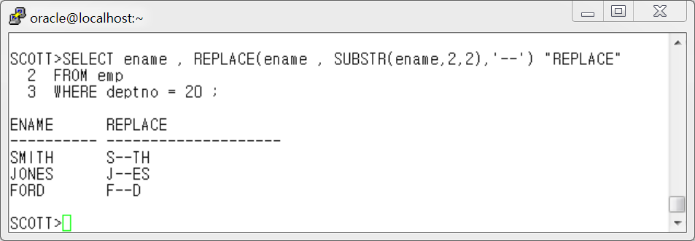

**- REPLACE 퀴즈 2 답 :**

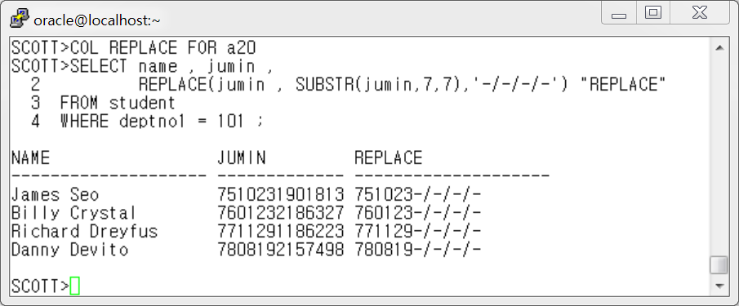

**- REPLACE 퀴즈 3 답:**

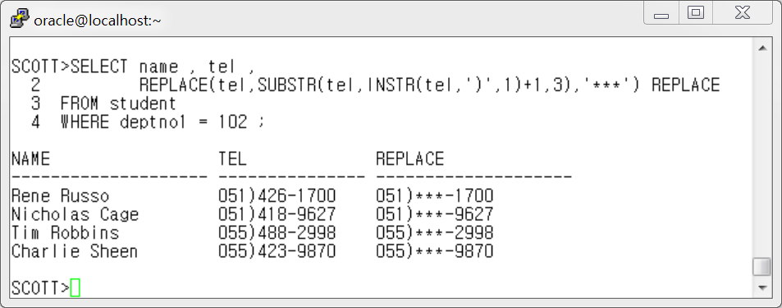

**- REPLACE 퀴즈 4 답:**

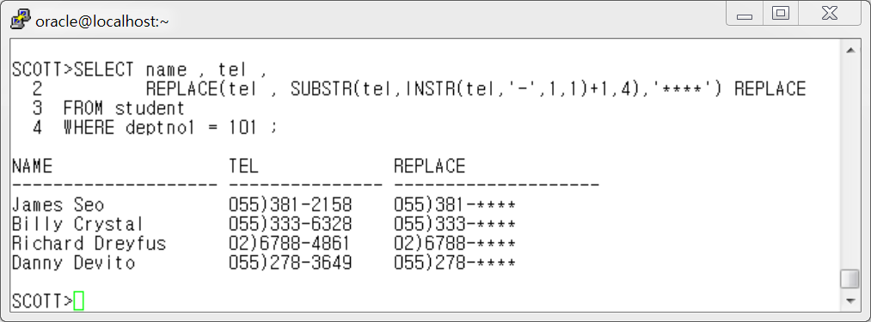

**- 형 변환 함수 퀴즈-날짜변환하기 1 \*\***

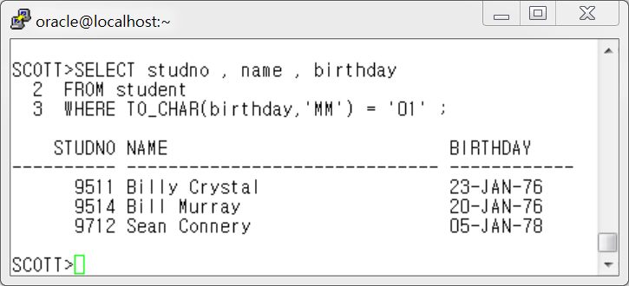

**- 형 변환 함수 퀴즈-날짜변환하기 2**

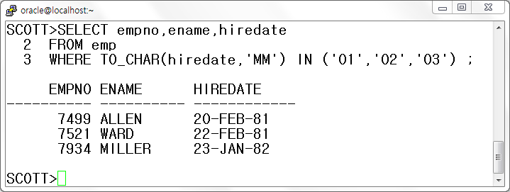

**- 형변환 함수 퀴즈 3**

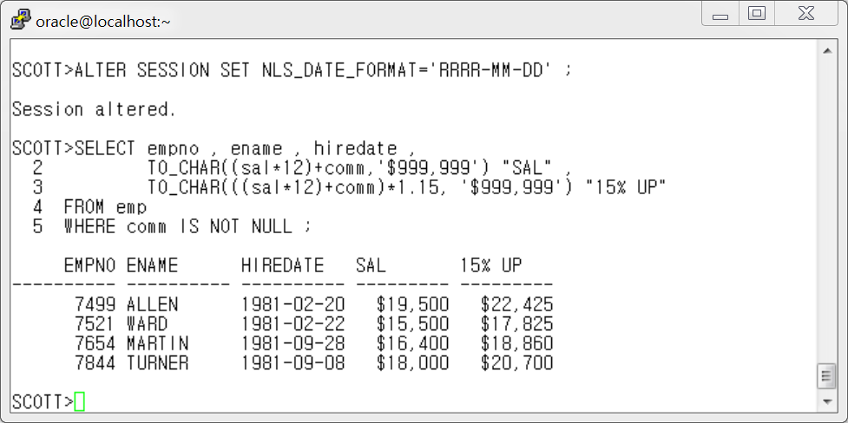

**- NVL 함수 퀴즈**

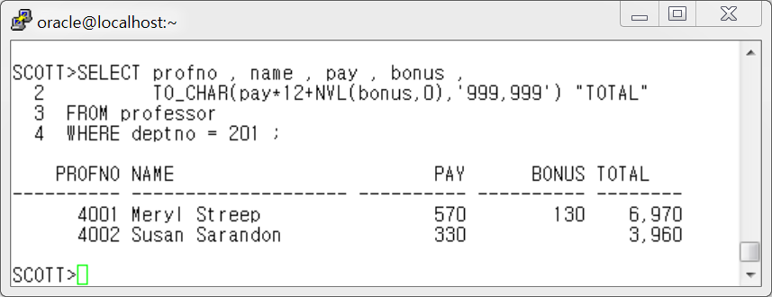

**- NVL2 함수 퀴즈**

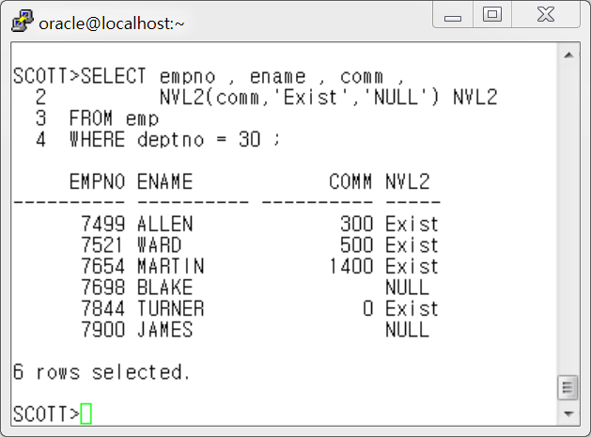

**- DECODE 연습 문제 1 답:**

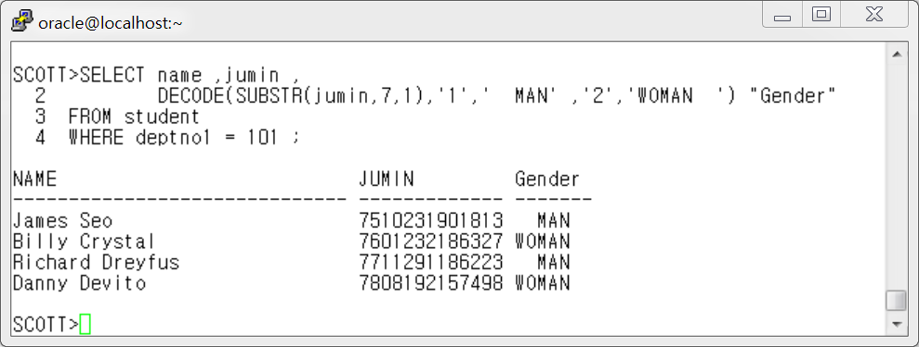

**- DECODE 연습 문제 2 답:**

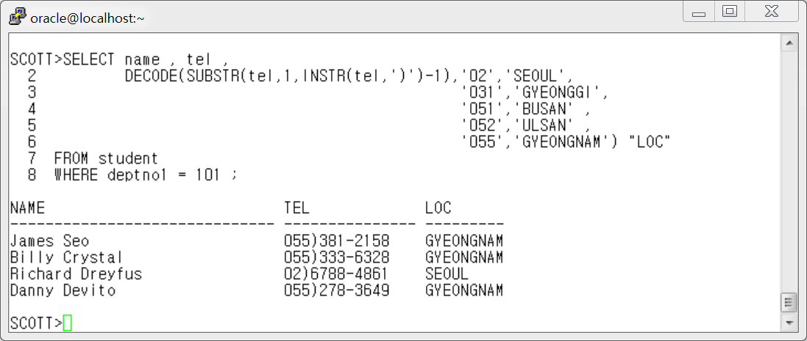

**- CASE 식 연습문제 답**

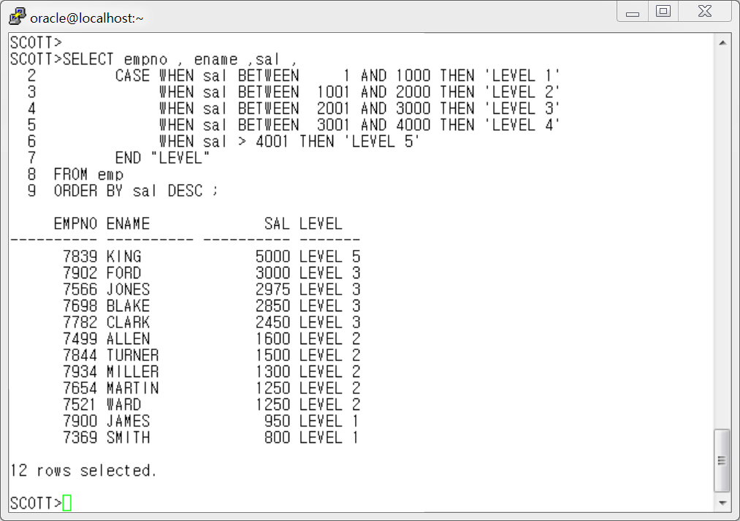

**< 3장 그룹함수 연습문제 해답>**

**- 1번 답 :**

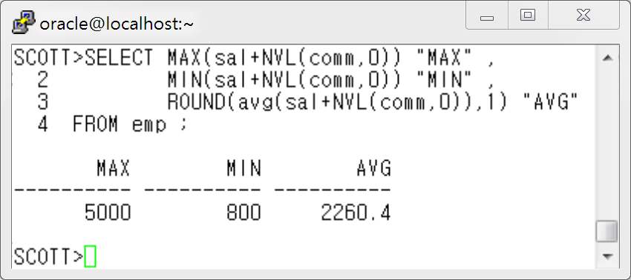

**- 2번 답 :**

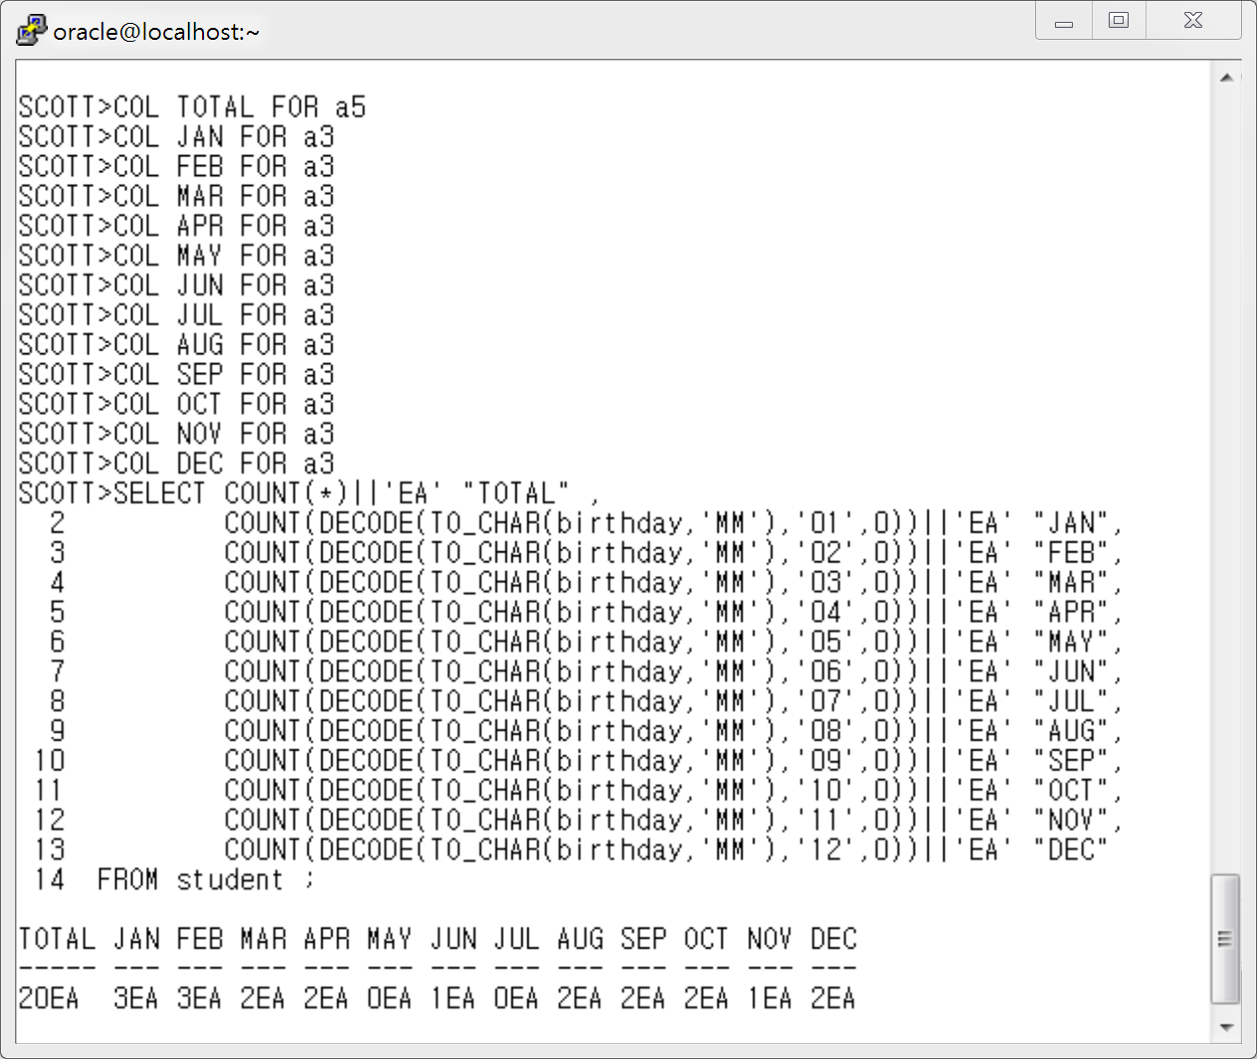

**- 3 번 답:**

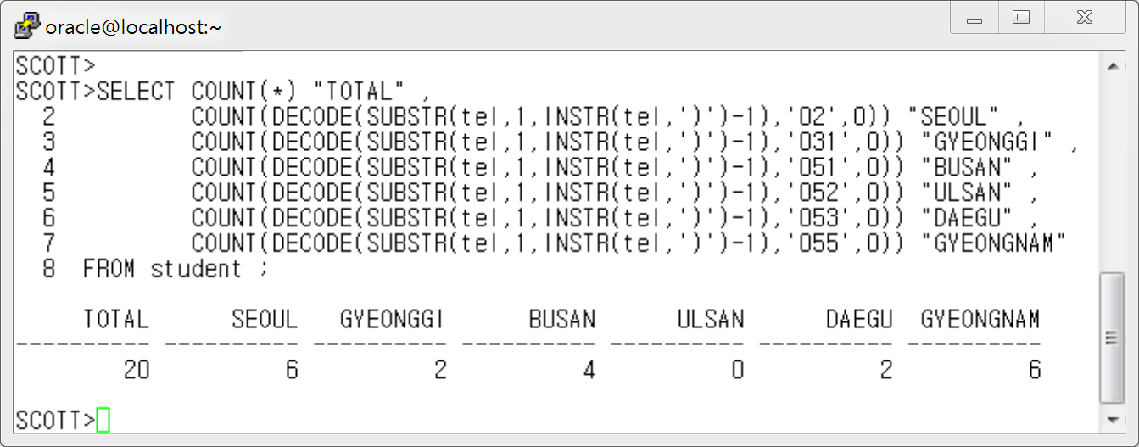

**4 번 답 :**

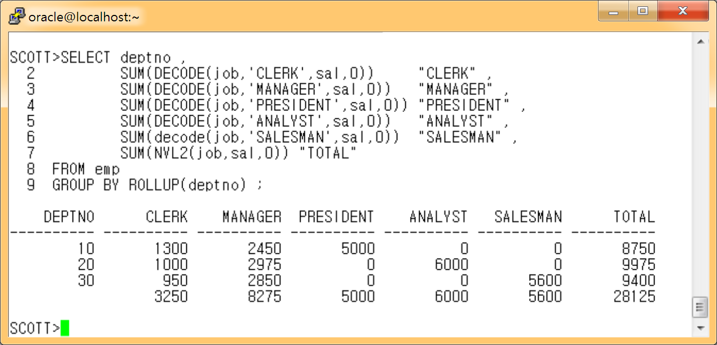

**5 번 답 :**

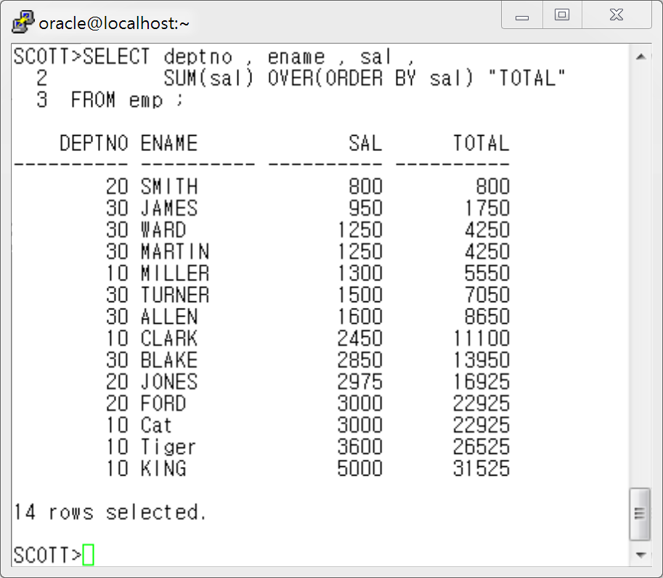

**6 번 답 :**

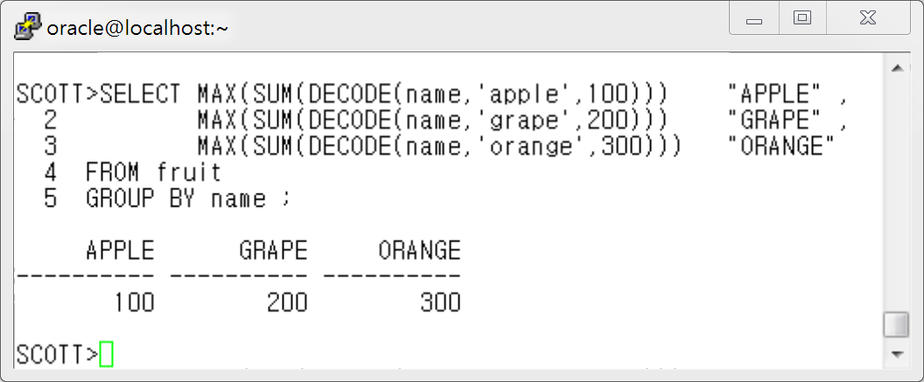

**7번 답:**

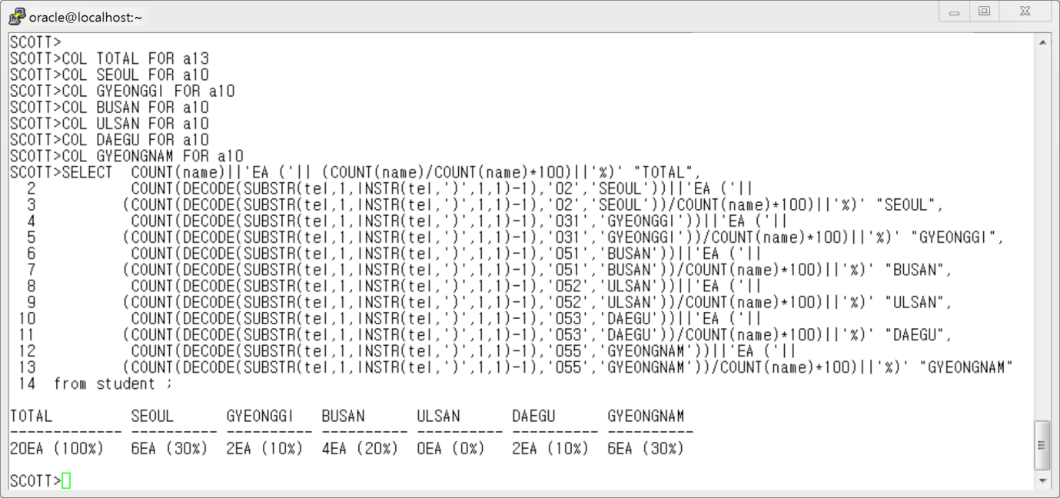

SCOTT>COL TOTAL FOR a13

SCOTT>COL SEOUL FOR a10

SCOTT>COL GYEONGGI FOR a10

SCOTT>COL BUSAN FOR a10

SCOTT>COL ULSAN FOR a10

SCOTT>COL DAEGU FOR a10

SCOTT>COL GYEONGNAM FOR a10

SCOTT>SELECT COUNT(name)||'EA ('|| (COUNT(name)/COUNT(name)*100)||'%)' "TOTAL",

2 COUNT(DECODE(SUBSTR(tel,1,INSTR(tel,')',1,1)-1),'02','SEOUL'))||'EA ('||

3 (COUNT(DECODE(SUBSTR(tel,1,INSTR(tel,')',1,1)-1),'02','SEOUL'))/COUNT(name)*100)||'%)' "SEOUL",

4 COUNT(DECODE(SUBSTR(tel,1,INSTR(tel,')',1,1)-1),'031','GYEONGGI'))||'EA ('||

5 (COUNT(DECODE(SUBSTR(tel,1,INSTR(tel,')',1,1)-1),'031','GYEONGGI'))/COUNT(name)*100)||'%)' "GYEONGGI",

6 COUNT(DECODE(SUBSTR(tel,1,INSTR(tel,')',1,1)-1),'051','BUSAN'))||'EA ('||

7 (COUNT(DECODE(SUBSTR(tel,1,INSTR(tel,')',1,1)-1),'051','BUSAN'))/COUNT(name)*100)||'%)' "BUSAN",

8 COUNT(DECODE(SUBSTR(tel,1,INSTR(tel,')',1,1)-1),'052','ULSAN'))||'EA ('||

9 (COUNT(DECODE(SUBSTR(tel,1,INSTR(tel,')',1,1)-1),'052','ULSAN'))/COUNT(name)*100)||'%)' "ULSAN",

10 COUNT(DECODE(SUBSTR(tel,1,INSTR(tel,')',1,1)-1),'053','DAEGU'))||'EA ('||

11 (COUNT(DECODE(SUBSTR(tel,1,INSTR(tel,')',1,1)-1),'053','DAEGU'))/COUNT(name)*100)||'%)' "DAEGU",

12 COUNT(DECODE(SUBSTR(tel,1,INSTR(tel,')',1,1)-1),'055','GYEONGNAM'))||'EA ('||

13 (COUNT(DECODE(SUBSTR(tel,1,INSTR(tel,')',1,1)-1),'055','GYEONGNAM'))/COUNT(name)*100)||'%)' "GYEONGNAM"

14 from student ;

TOTAL SEOUL GYEONGGI BUSAN ULSAN DAEGU GYEONGNAM

------------- ---------- ---------- ---------- ---------- ---------- ----------

20EA (100%) 6EA (30%) 2EA (10%) 4EA (20%) 0EA (0%) 2EA (10%) 6EA (30%)

**8번 답:**

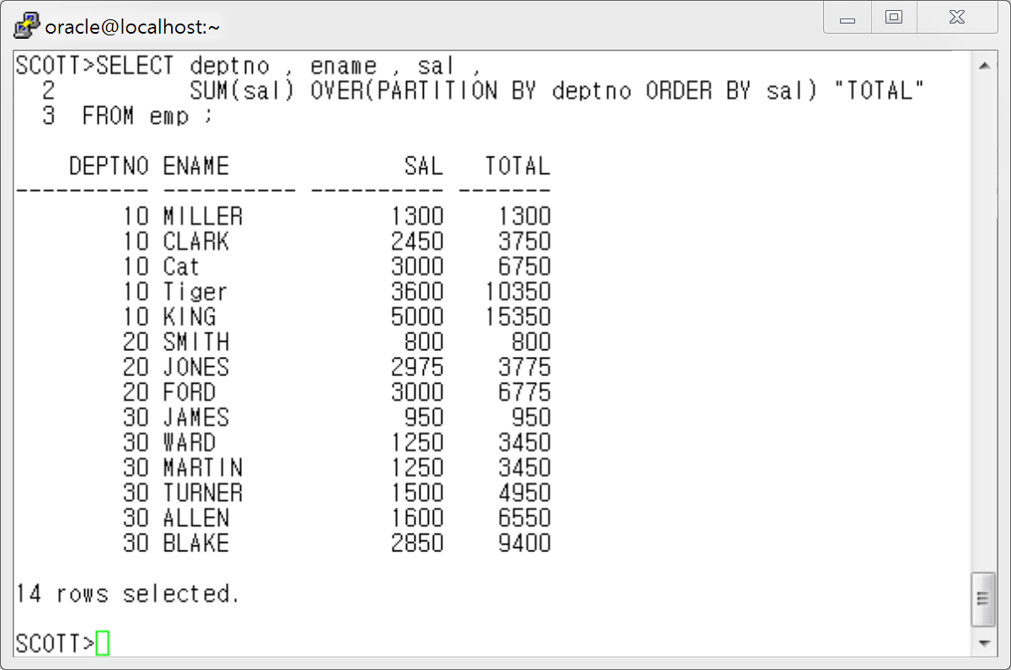

**9번 답 :**

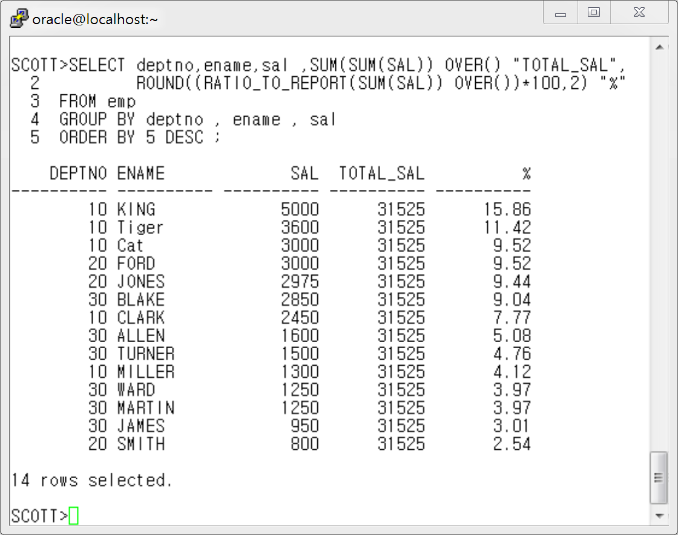

**10번 답 :**

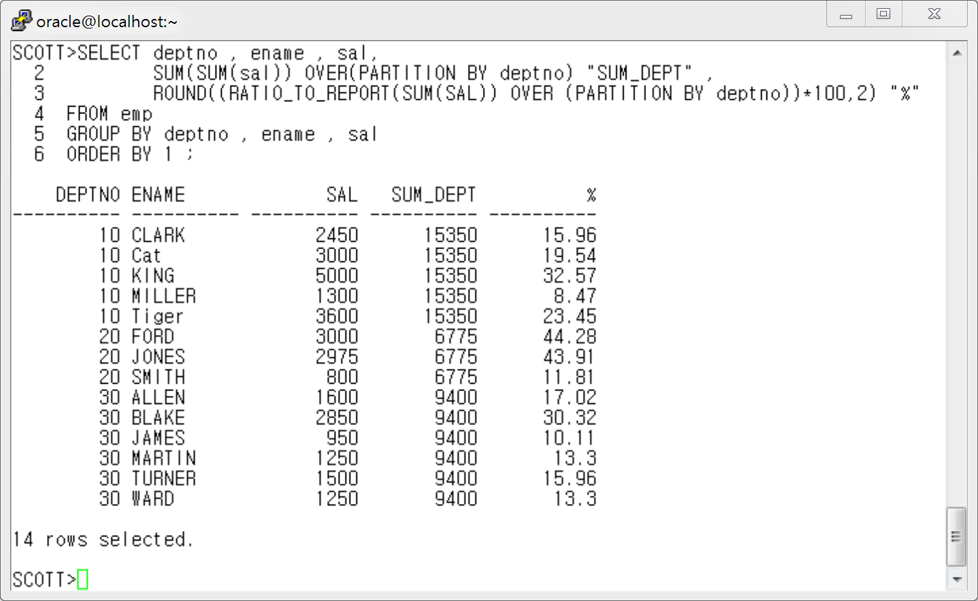

**11번답 )**

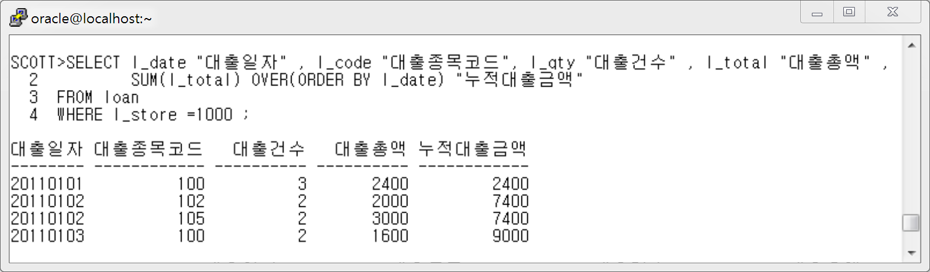

**12번 답)**

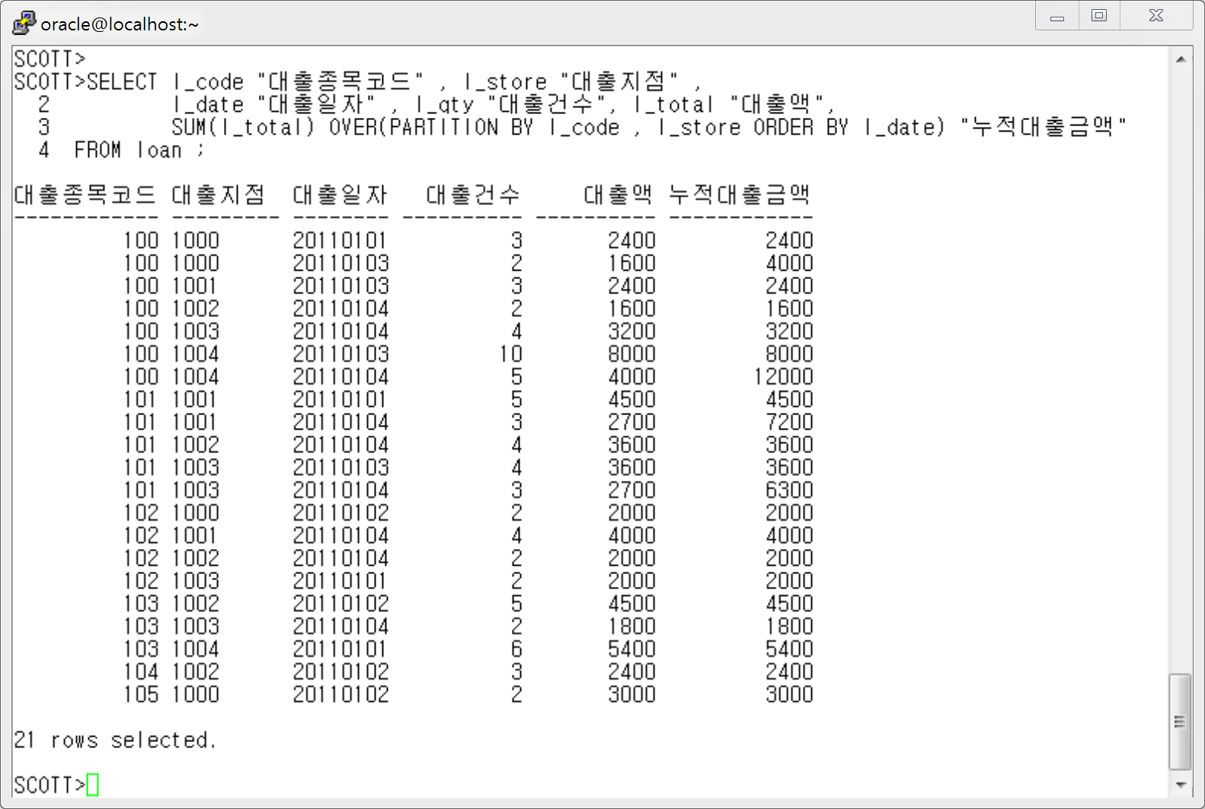

**13번 답)**

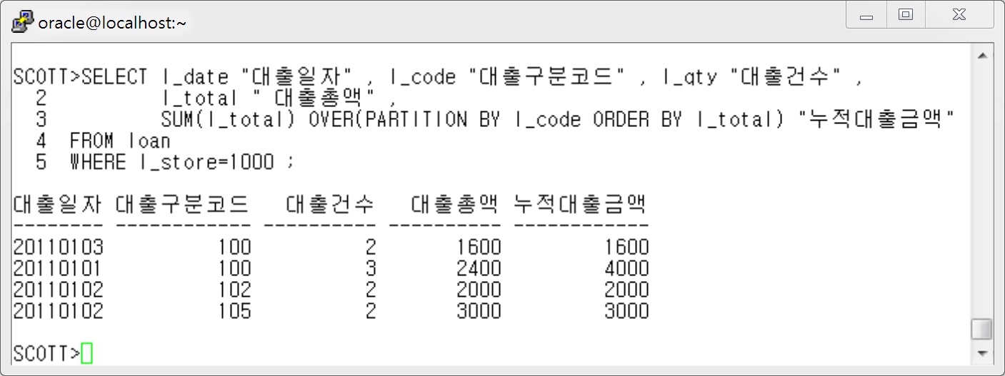

**14번 답)**

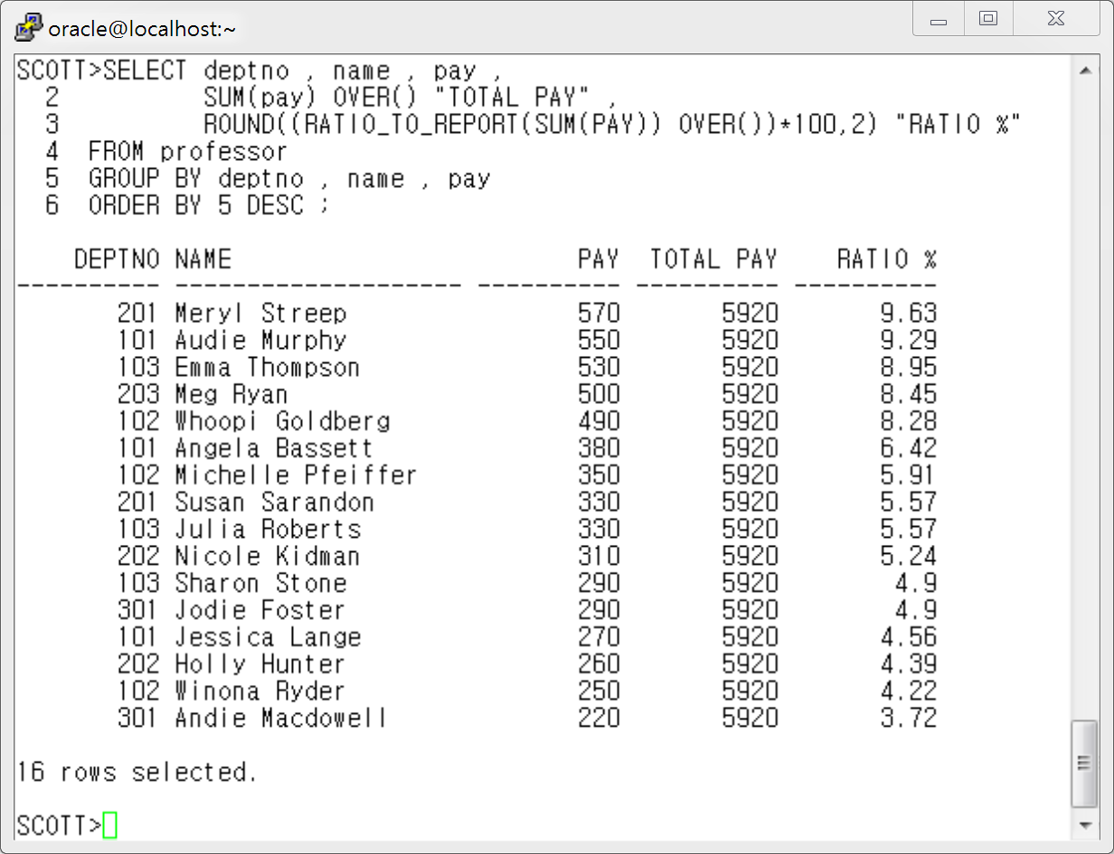

**15번 답)**

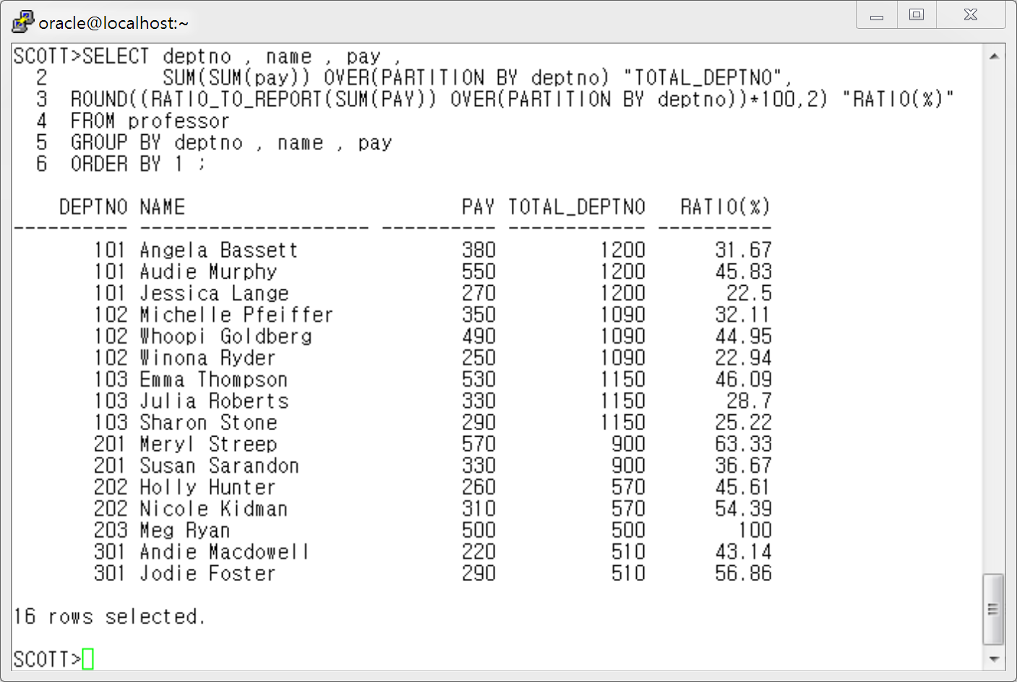

**< 4장 Join 연습문제 해답>**

**1 번 답)**

**[ Oracle Join 문법 ]**

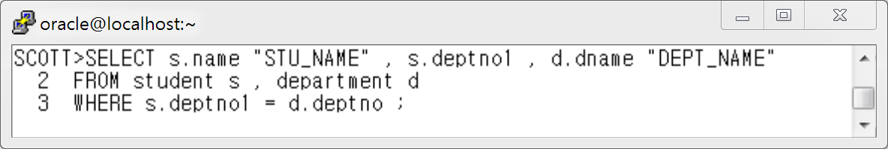

**[ ANSI Join 문법 ]**

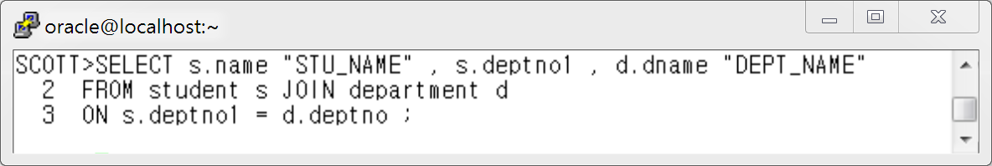

**2 번 답 )**

**[ Oracle Join 문법 ]**

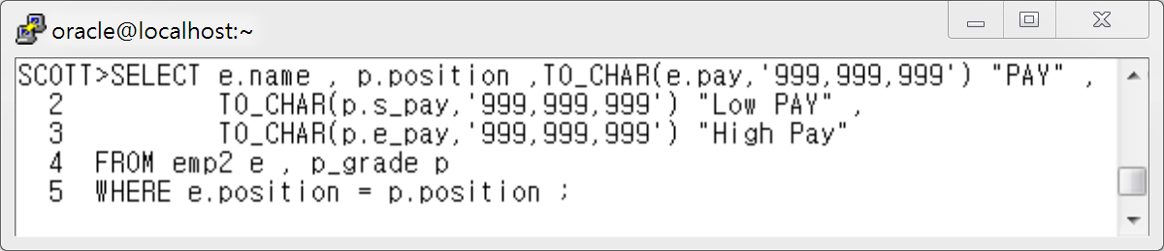

**[ ANSI Join 문법 ]**

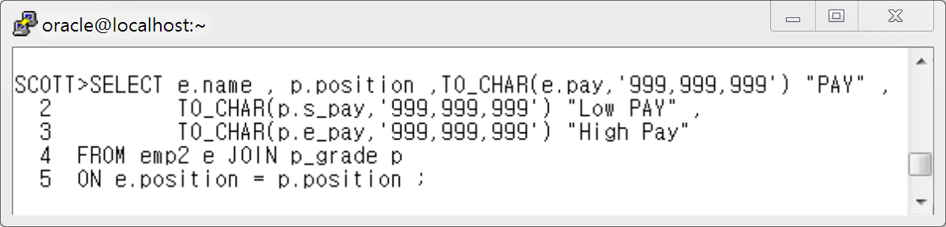

**3번 답)**

**[ Oracle Join 문법 ]**

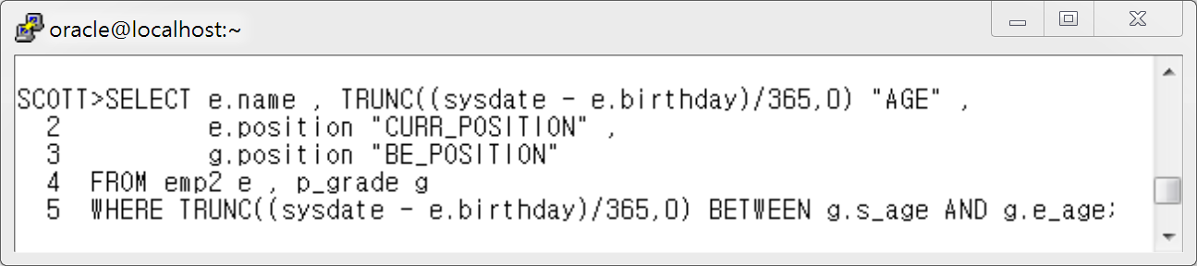

**[ ANSI Join 문법 ]**

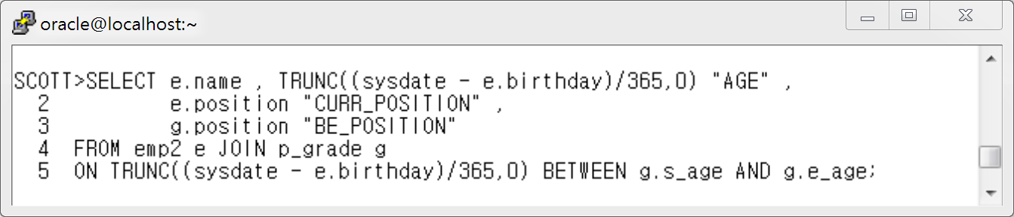

**4번 답)**

**[ Oracle Join 문법 ]**

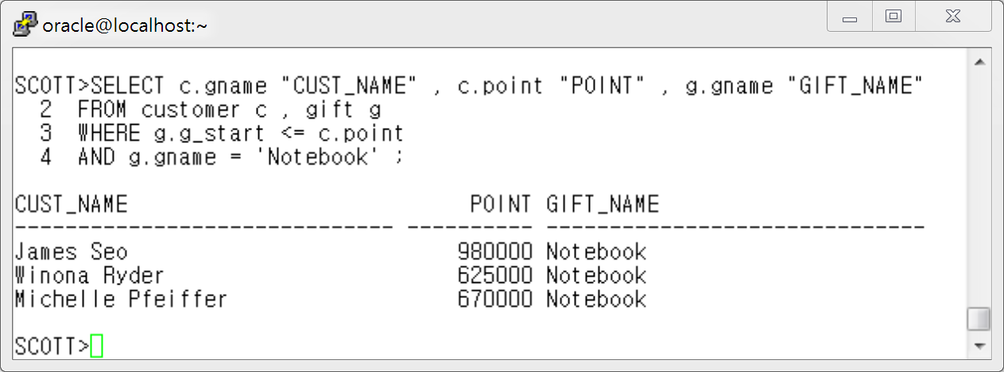

**[ ANSI Join 문법 ]**

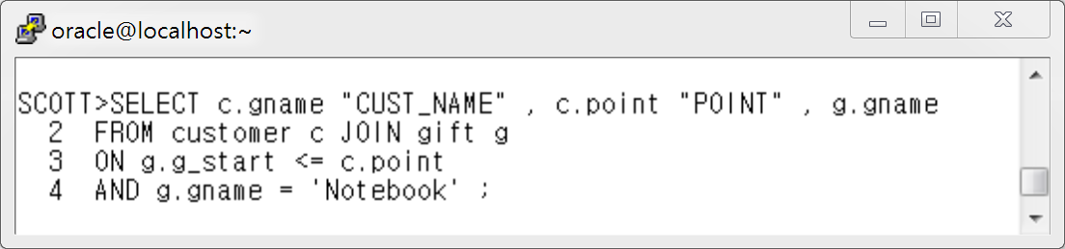

**5번 답)**

**[ Oracle Join 문법 ]**

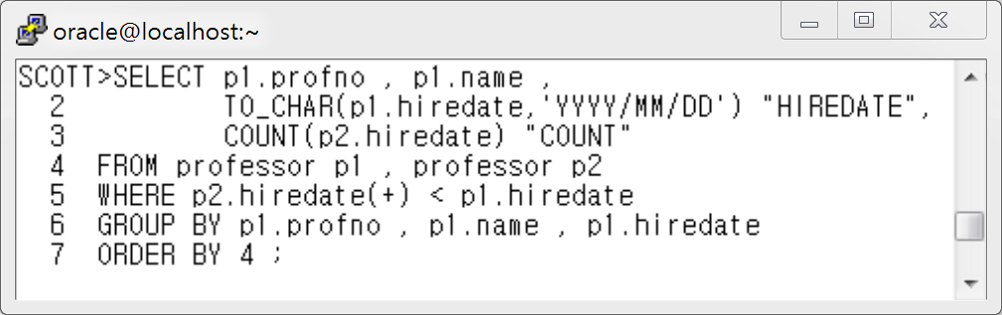

**[ ANSI Join 문법 ]**

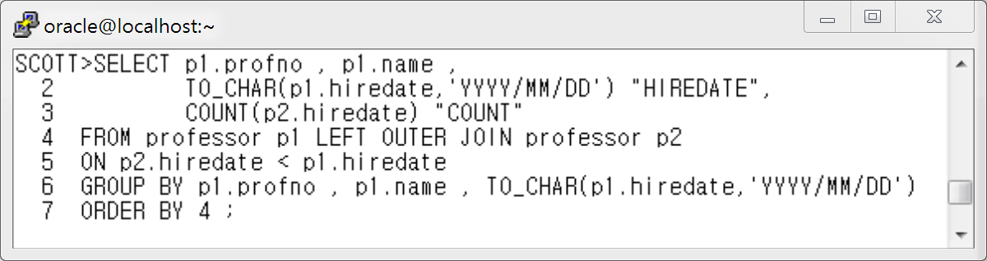

**6번 답 )**

**[ Oracle Join 문법 ]**

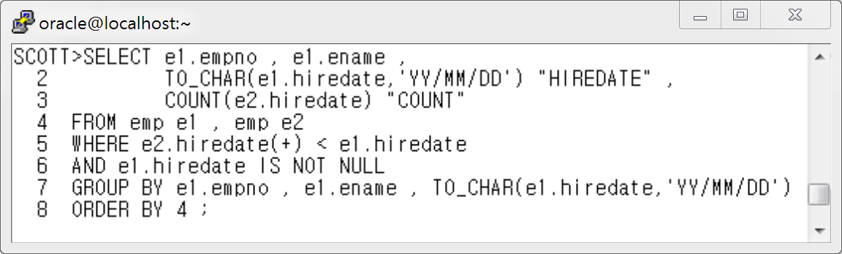

**[ ANSI Join 문법 ]**

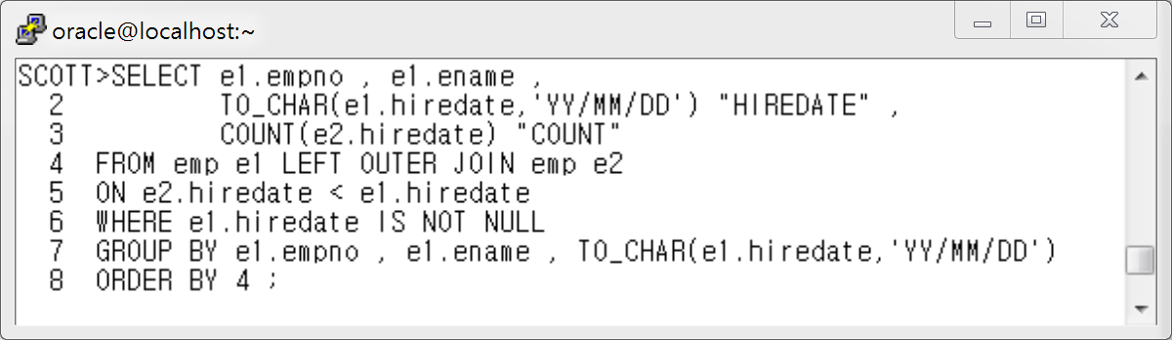

**< 5장 DDL 연습문제 답 >**

**- 1번 답 :**

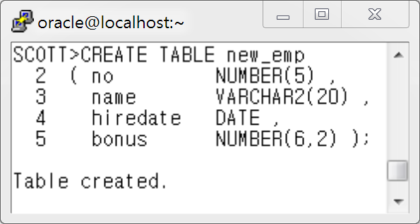

**- 2번 답 :**

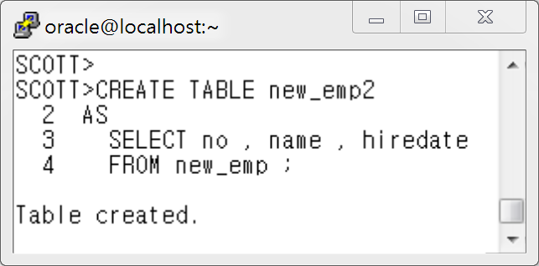

**- 3번 답 :**

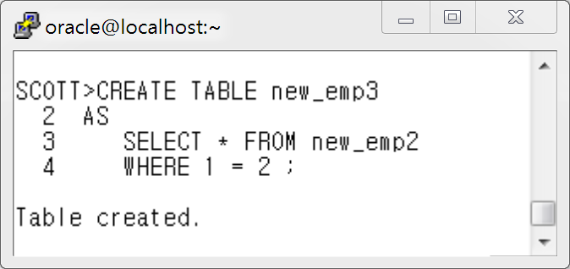

**-4번 답 :**

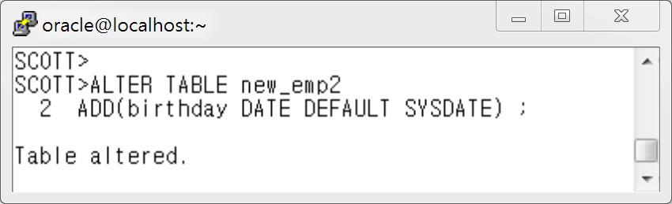

**- 5번 답 :**

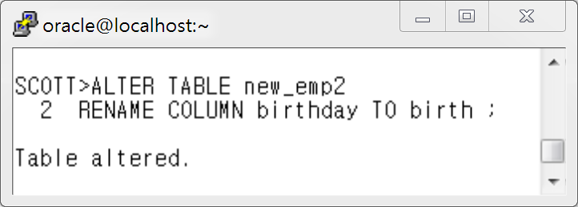

**- 6번 답 :**

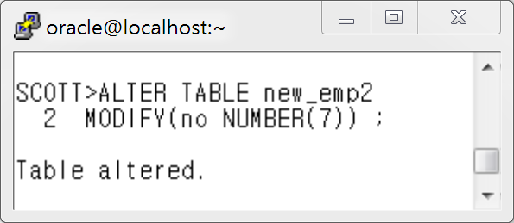

**- 7번 답 :**

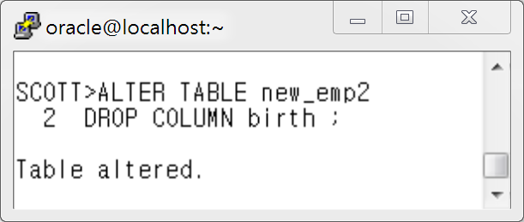

**-8번 답 :**

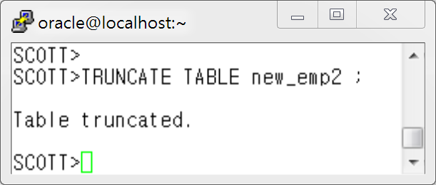

**-9번 답 :**

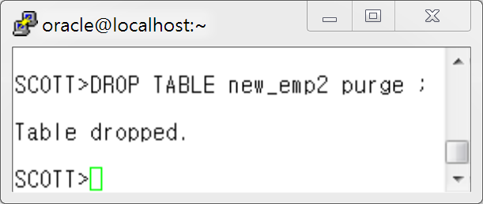

**<6 장 DML 연습문제 정답>**

* **1번 답: INSERT INTO dept2 VALUES('9010','temp_10','1006','temp area') ;**
* **2번 답: INSERT INTO dept2(DCODE , DNAME , PDEPT) VALUES('9020','temp_20','1006') ;**
* **3번 답:**

**INSERT INTO professor4**

**SELECT profno, name, pay**

**FROM professor**

**WHERE profno <= 3000 ;**

* **4번 답:**

**UPDATE professor**

**SET bonus = 100**

**WHERE name = ''Sharon Stone' ;**

**<7장 연습문제 정답>**

* **1번 답 :**

CREATE TABLE tcons

( no NUMBER(4)

CONSTRAINT tcons_no_pk PRIMARY KEY ,

name VARCHAR2(20)

CONSTRAINT tcons_name_nn NOT NULL,

jumin VARCHAR2(13)

CONSTRAINT tcons_jumin_nn NOT NULL

CONSTRAINT tcons_jumin_uk UNIQUE ,

area NUMBER(1)

CONSTRAINT tcons_area_ck CHECK ( loc_code < 5 ),

deptno VARCHAR2(6)

CONSTRAINT tcons_deptno_fk REFERENCES dept2(dcode)

) ;

* **2번 답:**

ALTER TABLE tcons

ADD CONSTRAINT tcons_name_fk FOREIGN KEY(name)

REFERENCES emp2(name) ;

* **3번 답:**

ALTER TABLE tcons

DISABLE VALIDATE CONSTRAINT tcons_jumin_uk ;

* **4번 답:**

ALTER TABLE scott.tcons ENABLE VALIDATE CONSTRAINT tcons_jumin_uk

EXCEPTIONS INTO scott.execptions;

* **5번 답:**

SELECT owner , constraint_name , table_name , column_name

FROM user_cons_columns

WHERE table_name='EMP';

**<9 장 View 연습문제 정답>**

**- 1번 답 :**

SCOTT>CREATE OR REPLACE VIEW v_prof_dept

2 AS

3 SELECT p.profno "교수번호"

4 , p.name "교수명"

5 , d.dname "소속학과명"

6 FROM professor p , department d

7 WHERE p.deptno = d.deptno ;

**- 2번 답 :**

SCOTT> SELECT d.dname

2 , s.max_height

3 , s.max_weight

4 FROM **( SELECT deptno1, MAX(height) max_height, MAX(weight) max_weight**

5 **FROM student**

6 **GROUP BY deptno1) s** , department d

7 WHERE s.deptno1 = d.deptno ;

**- 3번 답 :**

SCOTT> SELECT d.dname , a.max_height , s.name , s.height

2 FROM **( SELECT deptno1, MAX(height) max_height**

3 **FROM student**

4 **GROUP BY deptno1) a** , student s, department d

5 WHERE s.deptno1=a.deptno1

6 AND s.height = a.max_height

7 AND s.deptno1=d.deptno ;

**- 4번 답 :**

SCOTT>SELECT s.grade , s.name , s.height , a.avg_height

2 FROM **( SELECT grade , AVG(height) avg_height**

3 **FROM student**

4 **GROUP BY grade) a** , student s

5 WHERE a.grade = s.grade

6 AND s.height > a.avg_height

7 ORDER BY 1 ;

**- 5번 답:**

SCOTT>SELECT rownum "Ranking" , name , pay

2 FROM ( SELECT name , pay

3 FROM professor

4 ORDER BY 2 desc )

5 WHERE rownum BETWEEN 1 and 5 ;

**- 6번 답:**

SCOTT>SELECT num , profno , name , pay ,sum(pay) , round(avg(pay),1)

2 FROM (SELECT profno , name , pay , rownum num

3 FROM professor )

4 GROUP BY CEIL(num/3) , ROLLUP((profno , name , pay , num))

5 ORDER BY CEIL(num/3) ;

**< 10장 Sub Query 연습문제 해답>**

**단일행 서브쿼리 문제 1 답**

SCOTT> SELECT s.name "STUD_NAME" , d.dname "DEPT_NAME"

2 FROM student s , department d

3 WHERE s.deptno1=d.deptno

4 and s.deptno1 = ( **SELECT deptno1**

5 **FROM student**

6 **WHERE name='Anthony Hopkins') ;**

**단일행 서브쿼리 연습문제 2 답**

SCOTT>SELECT p.name "PROF_NAME" , p.hiredate ,d.dname "DEPT_NAME"

2 FROMprofessor p , department d

3 WHERE p.deptno = d.deptno

4 AND hiredate > ( **SELECT hiredate**

5 **FROM professor**

6 **WHERE name='Meg Ryan') ;**

**단일행 서브쿼리 연습문제 3 답:**

SCOTT>SELECT name , weight

2 FROM student

3 WHERE weight > ( **SELECT avg(weight)**

4 **FROM student**

5 **WHERE deptno1=201) ;**

**다중행 서브쿼리 연습문제 1 답:**

SCOTT> SELECT name , position ,

2 TO_CHAR(pay,'$999,999,999') "SALARY"

3 FROM emp2

4 WHERE pay **> ANY (SELECT pay**

5 **FROM emp2**

6 **WHERE position='Section head') ;**

**다중행 서브쿼리 연습문제 2 답:**

SCOTT> SELECT name , grade , weight

2 FROM student

3 WHERE weight **< ALL (SELECT weight**

4 **FROM student**

5 **WHERE grade = 2 ) ;**

**다중 행 서브쿼리 연습문제 3 답:**

SCOTT>SELECT d.dname , e.name ,to_char( e.pay,'$999,999,999') "SALARY"

2 FROM emp2 e , dept2 d

3 WHERE e.deptno=d.dcode

4 AND e.pay **< ALL (SELECT AVG(pay)**

5 **FROM emp2**

6 **GROUP BY deptno )**

7 ORDER BY 3 ;

**다중 컬럼 서브쿼리 연습문제 1 답 :**

SCOTT>SELECT p.profno "PROFNO" ,p.name "PROF_NAME",

2 p.hiredate , d.dname "DEPT_NAME"

3 FROM professor p , department d

4 WHERE p.deptno=d.deptno

5 AND (p.deptno , p.hiredate) **IN (SELECT deptno,MIN(hiredate)**

6 **FROM professor**

7 **GROUP BY deptno )**

8 ORDER BY 3 ;

**다중 컬럼 서브쿼리 연습문제 2 답:**

SCOTT>SELECT name , position , TO_CHAR(pay,'$999,999,999') "SALARY"

2 FROM emp2

3 WHERE (position,pay) **IN ( SELECT position, MAX(pay)**

4 **FROM emp2**

5 **GROUP BY position )**

6 ORDER BY 3 ;

**< 12장 계층형 쿼리 연습문제 답>**

**- 1번 답:**

SCOTT> SELECT LPAD(e.name||'-'||d.dname||'-'||

2 NVL(e.position,'Worker'),LEVEL*27,'-') "Name And Position"

3 FROM emp2 e, (SELECT dname,dcode,pdept

4 FROM dept2) d

5 WHERE e.deptno = d.dcode

6 CONNECT BY PRIOR e.empno = e.pempno

7 START WITH e.empno = 19900101 ;

- 1번-2 답:

SCOTT> SELECT LPAD(e.name||'-'||d.dname||'-'||

2 NVL(e.position,'Worker'),LEVEL*27,'-') "Name And Position"

3 FROM emp2 e, (SELECT dname,dcode,pdept

4 FROM dept2) d

5 WHERE e.deptno = d.dcode

6 CONNECT BY PRIOR e.empno = e.pempno

7 START WITH e.empno = 19900101

8 **ORDER SIBLINGS BY e.name ;**

**- 2번 답:**

SCOTT> SELECT LPAD(e.name||'-'||d.dname||'-'||

2 NVL(e.position,'Worker'),LEVEL*27,'-') "Name And Position"

3 FROM emp2 e, (SELECT dname,dcode,pdept

4 FROM dept2) d

5 WHERE e.deptno = d.dcode

6 CONNECT BY PRIOR e.empno = e.pempno

7 START WITH e.empno = 19966102 ;

**- 3번 답:**

SCOTT> SELECT

2 LPAD(e.name||'-'||d.dname||'-'||NVL(e.position,'Worker'),LEVEL*25,'-') "Name And Position"

3 FROM emp2 e, (SELECT dname,dcode,pdept

4 FROM dept2) d

5 WHERE e.deptno = d.dcode

6 CONNECT BY e.empno = PRIOR e.pempno

7 START WITH e.empno = 20000334 ;

**- 4번 답:**

SCOTT> SELECT name "NAME" , PRIOR name "MGR_NAME"

2 FROM emp2

3 START WITH pempno IS NULL

4 CONNECT BY PRIOR empno=pempno ;

**- 5번 답:**

SCOTT>COL ename FOR a58

SCOTT>SELECT empno , name||'-'||d.dname||'-'||NVL(a.position,'Worker') "ENAME" ,

2 (SELECT COUNT(*)

3 FROM emp2

4 START WITH empno = a.empno

5 CONNECT BY PRIOR empno = pempno) -1 "COUNT"

6 FROM emp2 a , ( SELECT dname , dcode

7 FROM dept2 ) d

8 WHERE a.deptno = d.dcode

9 ORDER BY 3 DESC ;

**6번 답**

SCOTT>COL "Name And Position" FOR a70

SCOTT>COL "PATH" FOR a50

SCOTT>SELECT

2 LPAD(e.name||' '||d.dname||' '||NVL(e.position,'Worker'),LEVEL*18,'-') "Name And Position"

3 ,SYS_CONNECT_BY_PATH(e.name,'-') "PATH"

4 FROM emp2 e, (SELECT dname,dcode,pdept

5 FROM dept2) d

6 WHERE e.deptno = d.dcode

7 CONNECT BY PRIOR e.empno = e.pempno ;

8 START WITH e.empno = 19966102 ;

**< 15장 PL/SQL 변수사용하기 연습문제 답 >**

**1번 답 :**

SCOTT>SET SERVEROUTPUT ON ;

SCOTT>DECLARE

**2 v_empno emp.empno%TYPE ;**

**3 v_ename emp.ename%TYPE ;**

**4 v_deptno dept.deptno%TYPE ;**

**5 v_dname dept.dname%TYPE ;**

6

7 BEGIN

8 SELECT e.empno, e.ename, d.deptno, d.dname

9 INTO v_empno, v_ename, v_deptno, v_dname

10 FROM emp e, dept d

11 WHERE e.empno=7902

12 AND e.deptno=d.deptno ;

13 DBMS_OUTPUT.PUT_LINE('EMPNO//ENAME//DEPTNO//DNAME') ;

14 DBMS_OUTPUT.PUT_LINE(v_empno||' '||v_ename||' '||v_deptno||' '||v_dname) ;

15 END ;

16 /

EMPNO//ENAME//DEPTNO//DNAME

7902 FORD 20 RESEARCH

PL/SQL procedure successfully completed.

**2번 답 :**

SCOTT>SET VERIFY OFF

SCOTT>SET SERVEROUTPUT ON

SCOTT>DECLARE

**2 v_no1 NUMBER := &no1 ;**

**3 v_no2 NUMBER := &no2 ;**

**4 v_sum NUMBER ;**

5

6 BEGIN

7 v_sum := v_no1 + v_no2 ;

8 **DBMS_OUTPUT.PUT_LINE('FIRST: '||v_no1||', SECOND : '||v_no2||' , TOTAL : '||v_sum||);**

9 END ;

10 /

**<16장 PLSQL 제어문 익히기 연습문제 답 >**

**연습문제 1 답:**

SQL>DECLARE

2 vempno emp.empno%TYPE;

3 vename emp.ename%TYPE;

4 vcomm emp.comm%TYPE := NULL;

5 BEGIN

6 SELECT empno , ename , comm INTO vempno , vename , vcomm

7 FROM emp

**8 WHERE empno= &empno; -- 사원번호 입력 받기입니다**

9

**10 IF vcomm > 0 THEN**

**11 DBMS_OUTPUT.PUT_LINE (vename||' 사원의 보너스는 '||vcomm||'입니다');**

**12 ELSE**

**13 DBMS_OUTPUT.PUT_LINE (vename||' 사원의 보너스는 없습니다');**

**14 END IF ;**

15 END;

16 /

**연습문제 2 답:**

SQL>DECLARE

2 **v_empno emp.empno%TYPE := &eno ;**

3 v_ename emp.ename%TYPE ;

4 v_sal emp.sal%TYPE ;

5 v_segum NUMBER ;

6 BEGIN

7 SELECT ename, sal INTO v_ename, v_sal

8 FROM emp

9 WHERE empno = v_empno ;

10

**11 IF v_sal >= 5000 THEN**

**12 v_segum := v_sal * 0.05 ;**

**13 ELSIF v_sal BETWEEN 4000 AND 4999 THEN**

**14 v_segum := v_sal * 0.04 ;**

**15 ELSIF v_sal BETWEEN 3000 AND 3999 THEN**

**16 v_segum := v_sal * 0.03 ;**

**17 ELSIF v_sal BETWEEN 2000 AND 2999 THEN**

**18 v_segum := v_sal * 0.02 ;**

**19 ELSE**

**20 v_segum := v_sal * 0.01 ;**

**21 END IF ;**

22

23 DBMS_OUTPUT.PUT_LINE ('입력하신 사번 '||v_empno||' 님의 연봉은 '||

24 v_sal ||' 만원이고 , 세금은 '||v_segum||' 만원입니다') ;

25 END ;

26 /

Enter value for eno: 7900

입력하신 사번 7900 님의 연봉은 950 만원이고 , 세금은 9.5 만원입니다

PL/SQL procedure successfully completed.

연습문제 3번 답 :

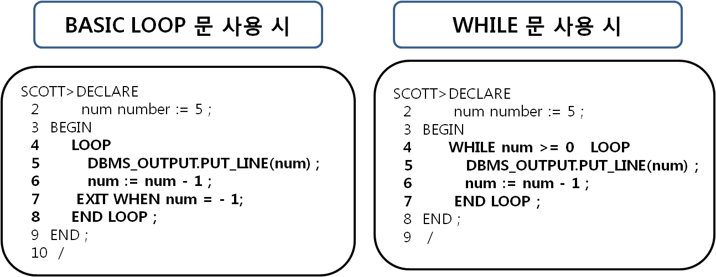

연습문제 4 답-for 반복문을 사용한 구구단 2단 출력하기

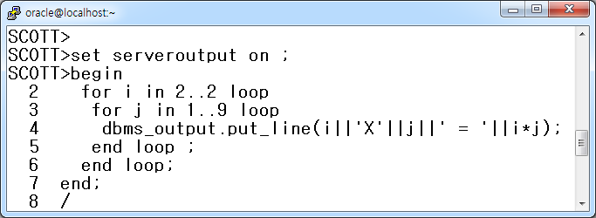

연습문제 4번 답-while 반복문을 사용한 구구단 2단 출력하기

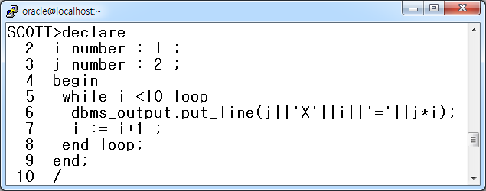

연습문제 5번 답 - for 반복문을 사용하여 원하는 단을 입력 받은 후 구구단 출력하기

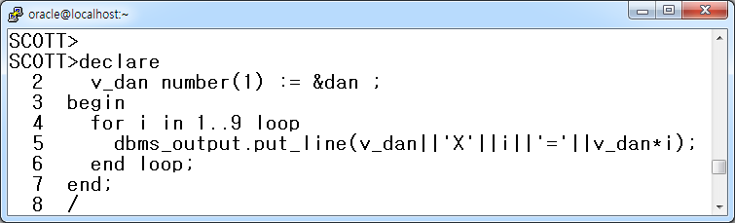

연습문제 5 답 - While 반복문을 사용하여 원하는 단을 입력 받은 후 구구단 출력하기

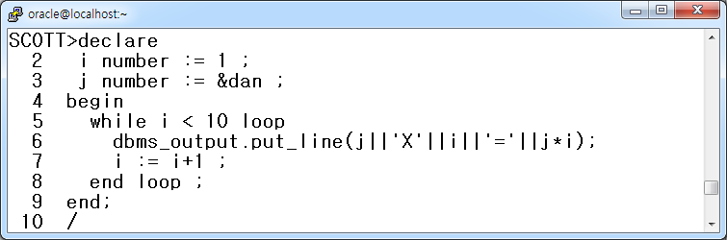

**< 17장. PLSQL CURSOR 연습문제 답 >**

**답 1.**

SQL> SET VERIFY OFF

SQL> SET SERVEROUTPUT ON

SQL> DECLARE

2 v_deptno NUMBER := &dno;

3 BEGIN

4 DELETE emp WHERE deptno = v_deptno;

5 DBMS_OUTPUT.PUT_LINE( '삭제 건수는 총 '|| SQL%ROWCOUNT||’ 건 입니다’);

6 END ;

7 /

Enter value for dno: 10

삭제 건수는 총 4 건 입니다

PL/SQL procedure successfully completed.

**답 2.**

SQL> SET VERIFY OFF

SQL> SET SERVEROUTPUT ON

SQL> DECLARE

2 CURSOR cur_emp IS

3 SELECT ename, sal

4 FROM emp

**5 WHERE deptno = &dno;**

6

7 v_ename emp.ename%TYPE;

8 v_sal emp.sal%TYPE;

9

10 BEGIN

11 OPEN cur_emp;

12 LOOP

13 FETCH cur_emp INTO v_ename,v_sal ;

14 EXIT WHEN cur_emp%NOTFOUND;

15 DBMS_OUTPUT.PUT_LINE(v_ename||' 의 급여는 '||v_sal||' 입니다');

16 END LOOP;

17 CLOSE cur_emp ;

18 END;

19 /

Enter value for dno: 20

SMITH 의 급여는 800 입니다

JONES 의 급여는 2975 입니다

SCOTT 의 급여는 3000 입니다

ADAMS 의 급여는 1100 입니다

FORD 의 급여는 3000 입니다

PL/SQL procedure successfully completed.

답 3.

SCOTT>alter session set nls_date_format='YYYY-MM-DD:HH24:MI:SS';

Session altered.

SCOTT>declare

2 vdname department.dname%type;

3 vbuild department.build%type;

4

5 cursor d_cur is

6 select dname,build

7 from department

8 where build is not null ;

9

10 begin

11 open d_cur ;

12 dbms_output.put_line(' 학과명과 학과의 위치 안내 입니다');

13 dbms_output.put_line('-------------------------------------------');

14

15 loop

16 fetch d_cur into vdname,vbuild;

17 exit when d_cur%notfound;

18 dbms_output.put_line(vdname||' ---> '||vbuild||' 에 있습니다');

19 end loop;

20

21 dbms_output.put_line('----------------------------------------------');

22 dbms_output.put_line('출력시간:'||sysdate) ;

23 dbms_output.put_line('총 '||d_cur%rowcount||' 건 출력 완료하였습니다');

24

25 close d_cur;

26 end;

27 /

**< 19장 Sub Program 연습문제 답 >**

**프로시저 연습문제 1 답 :**

SQL> CREATE OR REPLACE PROCEDURE new_man (

2 v_empno IN emp.empno%TYPE,

3 v_ename IN emp.ename%TYPE,

4 v_job IN emp.job%TYPE,

5 v_manager IN emp.mgr%TYPE,

6 v_sal IN emp.sal%TYPE)

7 IS

8 BEGIN

9 INSERT INTO emp(empno,ename,job,mgr,sal)

10 VALUES(v_empno,v_ename,v_job,v_manager,v_sal);

11 END;

12 /

**프로시저 연습문제 2 답:**

SQL> CREATE OR REPLACE PROCEDURE up_comm (

**2 v_deptno IN emp.deptno%TYPE )**

3 IS

**4 v_comm emp.comm%TYPE ;**

5 BEGIN

6 IF v_deptno = 10 THEN

7 UPDATE emp

8 SET comm = sal*0.2

9 WHERE deptno =v_deptno ;

10 ELSIF v_deptno = 20 THEN

11 UPDATE emp

12 SET comm = sal*0.3

13 WHERE deptno =v_deptno;

14 ELSIF v_deptno = 30 THEN

15 UPDATE emp

16 SET comm = sal*0.1

17 WHERE deptno=v_deptno;

18 ELSE

19 UPDATE emp

20 SET comm = sal * 0;

21 END IF ;

22 END up_comm;

23 /

위 예에서는 변수 2가지가 사용됩니다.

2번 줄과 4번 줄이 그 변수들입니다.

이 두 줄의 차이점은 2번 줄은 사용자에게서 값을 입력 받아 프로시져에게 전달해 주는 변수이며 4번 줄은 프로시저 실행시 프로시저 내부에서만 사용되는 변수입니다.

두 변수의 용도와 위치의 차이를 꼭 기억하세요~

**프로시저 연습문제 3 답:**

SCOTT>CREATE TABLE emp2

2 AS

3 SELECT * FROM EMP;

Table created.

SQL> CREATE OR REPLACE PROCEDURE del_user(

2 v_empno IN emp.empno%TYPE )

3 IS

4 BEGIN

5 DELETE FROM emp2 WHERE empno=v_empno;

6 end;

7 /

**프로시저 연습문제 4 답 :**

SQL > CREATE OR REPLACE PROCEDURE select_user(

2 v_empno IN emp.empno%TYPE )

3 IS

4 v_ename emp.ename%TYPE;

5 v_dname dept.dname%TYPE;

6 v_deptno emp.deptno%TYPE;

7 v_sal emp.sal%TYPE;

8 v_comm emp.comm%TYPE;

9 BEGIN

10 SELECT e.ename, d.dname, e.sal, e.comm

11 INTO v_ename, v_dname, v_sal, v_comm

12 FROM emp e, dept d

13 WHERE empno=v_empno

14 AND e.deptno=d.deptno;

15 DBMS_OUTPUT.PUT_LINE('사 번:'||v_empno);

16 DBMS_OUTPUT.PUT_LINE ('이 름:'||v_ename);

17 DBMS_OUTPUT.PUT_LINE ('부 서 명:'||v_dname);

18 DBMS_OUTPUT.PUT_LINE ('급 여:'||v_sal);

19 DBMS_OUTPUT.PUT_LINE ('상 여 금:'||v_comm);

20 END ;

21 /

**프로시저 연습문제 5 답:**

create or replace procedure d_cal(i_principal number, i_interest number, i_period number) is

cnt number := 1;

month_sang_sum number;

month_sang_wongum number;

month_interest number;

left_wongum number := 1;

pay_total number;

first float := i_principal * i_interest / 12 / ( power ( 1 + i_interest / 12 , 12 * i_period) - 1);

begin

month_sang_sum := round((i_principal * i_interest / 12 + first ));

pay_total := month_sang_sum * 12;

dbms_output.put_line(' ');

dbms_output.put_line(' -------------------------------'||' '||'대출금액:'||round(i_principal/10000.0,0)||'만원');

dbms_output.put_line(' | 대출 원리금 상환 계산기 |'||' '||'대출금리:'||i_interest*100.0||'%'||'('||to_char(i_interest,'0.99')||' )');

dbms_output.put_line(' -------------------------------'||' '||'대출기간:'||i_period||' 년('||i_period*12||'개월)');

dbms_output.put_line('=============================================================');

dbms_output.put_line(' ');

dbms_output.put_line(' 총납입개월:'||i_period*12||'개월/ '||'총납입금액:'||to_char(pay_total,'9,999,999')||'원/ ');

dbms_output.put_line(' 총납입원금:'||to_char(i_principal,'9,999,999')||'원/ '||'총납입이자:'||to_char(pay_total-i_principal,'99,999')||'원');

dbms_output.put_line('------------------------------------------------------------------------------');

dbms_output.put_line('상환 | 월 상 환 | 월상환 | 월상환 | 미 상 환 | 월상환원리금');

dbms_output.put_line('회차 | 원리금합계 | 원 금 | 이 자 | 원리금잔액 | 누적 합계액');

dbms_output.put_line('------------------------------------------------------------------------------'); -- 다음 장에서 계속 됩니다

pay_total := 0;

loop

exit when left_wongum = 0;

month_sang_wongum := round(first * power ( 1 + i_interest / 12 , cnt -1 ));

month_interest := round(i_principal * i_interest /12 + first - first * power ( 1 + i_interest / 12 , cnt -1));

left_wongum := round(i_principal - first * (power ( 1 + i_interest / 12 , cnt) - 1) / ( i_interest / 12 ));

pay_total := pay_total + month_sang_sum;

dbms_output.put_line('*'||to_char(cnt,'09')||' '||to_char(month_sang_sum,'999,999')||' 원 '

||to_char(month_sang_wongum,'999,999')||' 원 '

||to_char(month_interest,'999,999')||' 원 '

||to_char(left_wongum,'999,999')||' 원 '

||to_char(pay_total,'9,999,999')||' 원');

cnt := cnt + 1;

end loop;

end;

/